**2024: The Parking Lot is Completed**

Phase I of a long-planned building expansion project was completed when the parking lot in the adjacent, ECHO-owned property at 7209 Old Keene Mill Road opened on May 8, 2024. Completion of the lot allows the planning for Phase II—a 2,400 square foot expansion of the building--to begin. Chamberlain Construction broke ground on the lot on November 27, 2023. During construction, volunteers were able to park in the nearby Springfield United Methodist Church parking lot. The project involved a “wet pond” for stormwater management with a drainage pipe through a neighbor’s property to Lee Valley Drive and planting of 106 trees and 88 shrubs. The total cost of the project was $681,459.

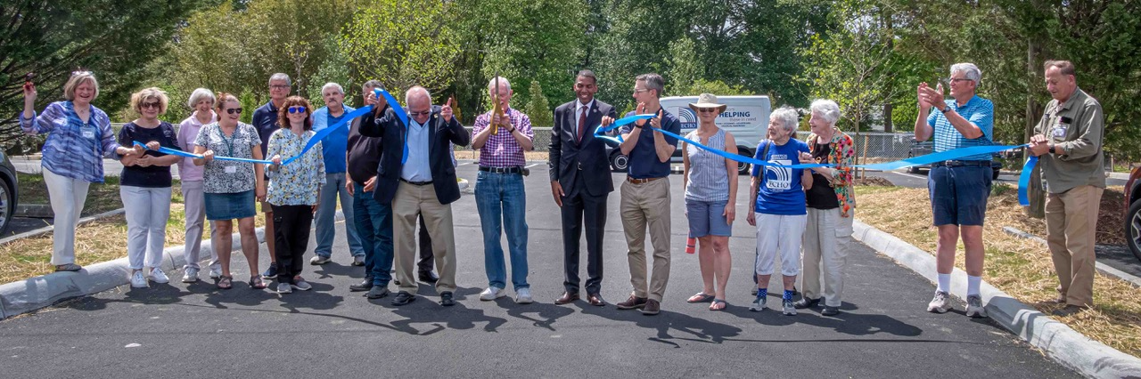May 8, 2024 ribbon-cutting ceremony

During the year ECHO updated its mission, vision, and values statements:

Mission: ECHO provides assistance to individuals/families in need within the Burke/Springfield community by offering food, clothing, housewares, and financial assistance for housing/utilities.

Vision: A community where ECHO partners with religious, civic, commercial, and governmental entities to identify and address unmet human needs, assists clients to access services that ECHO does not routinely provide, and reinforces, rather than duplicates, services provided by other organizations.

Values: We commit to and embrace our long-standing core values of Service, People, and Innovation:

* Service: We endeavor to strengthen our community by assisting all members of the community in achieving an acceptable standard of living.
* People: We value our donors, volunteers, and clients, and strive to treat all with respect and grace.
* Innovation: We foster efficiency in delivering assistance through innovative solutions that include the assessment of existing processes and integration of new technologies where appropriate.

ECHO continued all of its core programs. Rent assistance continued to be capped at one time per year but the amount was raised to $1,500. A shortage of Spanish-speaking volunteers remained an issue since over half of ECHO’s clients are Spanish-speaking.

The Food Choice format of the Food Room continued to be very popular. As demand increased, though, donations decreased. There was more of a disconnect between food items chosen by clients and food donations, as donors continued to bring in products like canned soup and green beans which aren’t popular choices. (These items are given to Medical Missionaries who sent them to communities in southwestern Virginia.) The volume of donations dropped, in part because many churches and schools have their own donation programs, and food drives didn’t yield the volume of food they once did. The Food Room received food donations averaging 18,000 pounds per month, but dispensed an average of 22,000 pounds per month. A $70,000 grant from Fairfax County enabled the purchase of food items and Fresh World food coupons to make up the difference.

The summer backpack program distributed 1,200 backpacks. The Holiday shop hosted 220 families and provided gifts to 550 children. The Thanksgiving meals program supported 250 families, while the Christmas program provided 200 meals. The Enrichment Bag program, involving provision of age and gender-appropriate items (something educational like a book, something soft like a stuffed animal, and something fun like Play-Doh), distributed 30-50 bags each week. The scholarship program provided six $1,000 NOVA scholarships each semester.

Partnerships with area non-profits, congregations, and businesses continued to provide substantial support. Abiding Presence Lutheran Church paid for two college seniors to serve as interns at ECHO. One served as a counselor auxiliary and the other provided media outreach support. Clyde’s of Georgetown donated 1,200 pounds of dishware. HomeAid gave ECHO 36 boxes of diapers. Gracing Spaces agreed to accept ECHO clients’ request for furniture. Fairfax County gave ECHO 500 COVID home test kits to give to clients. Fairfax County Supervisors Rodney Lusk (Franconia District), Pat Herrity (Springfield District) and James Walkinshaw (Braddock District) sponsored food donation boxes in their district offices. Summit Church sponsored donation boxes at Giant grocery stores in Saratoga, Cardinal Forest, and Springfield Plaza. The Target Foundation donated $2,500 to buy children’s coats and the Target Circle Charity program, whereby shoppers voted to support a charity, presented ECHO with a check for $4,844. Miller Office Supply donated 42 laptop and 10 desktop computers; twenty-eight laptops have been distributed to date, including ten prepared by the West Springfield High School Computer Science Honor Society students.

Upgrades to the ECHO building are ongoing. In 2024 they included completion of a project to install 100% non-ballasted LED lights which are 800% more efficient than fluorescent bulbs and will pay for themselves in energy savings within five years. New emergency lights with maintenance-free nickel-cadmium batteries will provide 90 minutes of emergency power and last ten years. New phones with Bluetooth headsets enable counselors to take calls hands-free and to move around the building while staying connected. The last three older donated ECHO computers were replaced, with a plan to replace three per year on a five-year replacement cycle.

To acknowledge its volunteers, ECHO sponsored its second annual picnic at Burke Lake Park. It provided pulled pork barbecue, fried chicken, and bottled water, and asked volunteers to bring salad, side dishes and/or dessert to share. For the safety of its volunteers, ECHO paid for the Red Cross to train 25 volunteers in emergency aid so there is at least one trained volunteer at almost every shift.